NAME: PAPAI MONDAL

REG NO.: RA2111028010116

COURSE: Database Management Systems and Cloud Integration Services (18CSC209J)

ASSIGNMENT 3- PART 1

**Q.1** Create a Movie table with MID, MNAME, Director, Producer, Movie-category, Actor, Year. Note:  
Insert the records with Actors as Karan,Thilak, producers as Arunachalam, Siva .

**ANS.**

CREATE TABLE Movie (

MID varchar(30),

Mname varchar(30),

Director varchar(30),

Producer varchar(30),

Movie_category varchar(30),

Actor varchar(30),

Year_release YEAR

);

INSERT INTO Movie VALUES('John', 'Doe', 'Anurag', 'Arunachalam', 'Horror', 'Karan', 2021);

INSERT INTO Movie VALUES('Robert', 'Luna', 'Rajamouli', 'Siva',' Action', 'Thilak', 2019);

INSERT INTO Movie VALUES('David', 'Robinson', 'Yash', 'Dhruv', 'Sci_Fi', 'Thilak', 2011);

INSERT INTO Movie VALUES('Betty', 'Reinhart', 'Siva', 'Siva', 'Action', 'Karan', 2022);

INSERT INTO Movie VALUES('Mary', 'Jane', 'Siva', 'Arunachalam','Romantic','Thilak', 2015);

INSERT INTO Movie VALUES('Johnathon', 'Silva', 'Shashi', 'Siva','Horror', 'Karan', 2023);

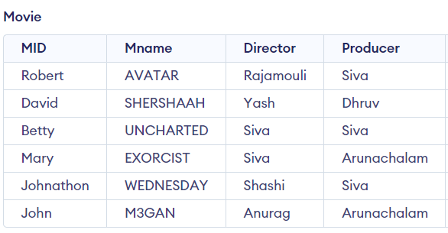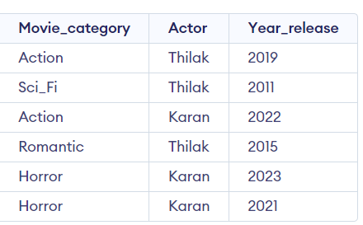

**Q.2** Find the movies casted by Karan.

**ANS**.

SELECT Mname from Movie where Actor ="Karan";

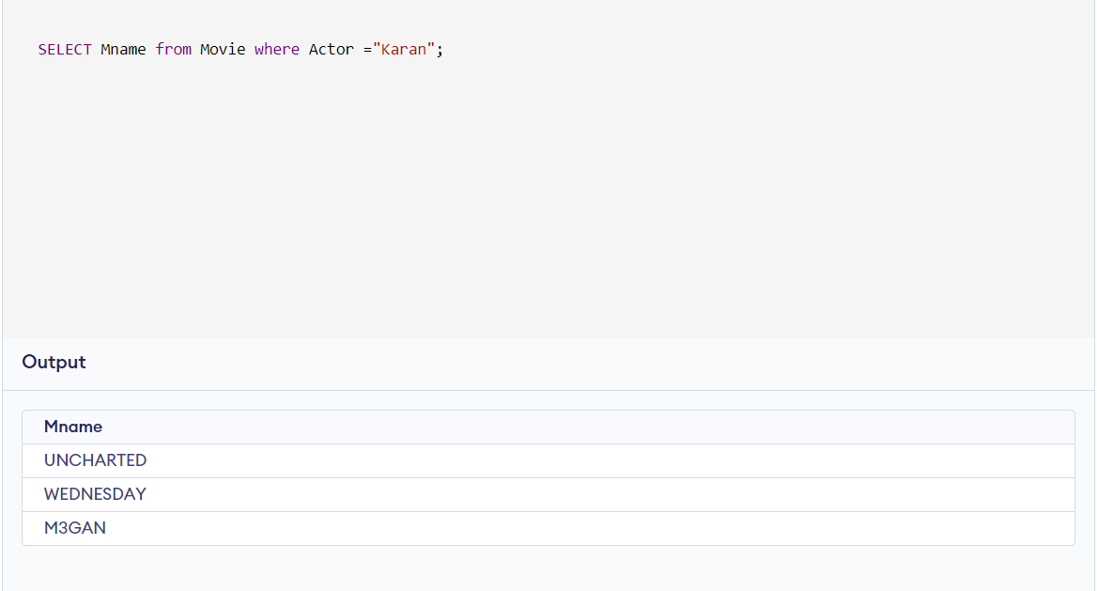

**Q.3** Find the movies released by the producer Siva and Director Siva during the last 5 years

**ANS.**

SELECT Mname from Movie where Producer= 'Siva'AND Director='Siva'AND Year_release> 2017;

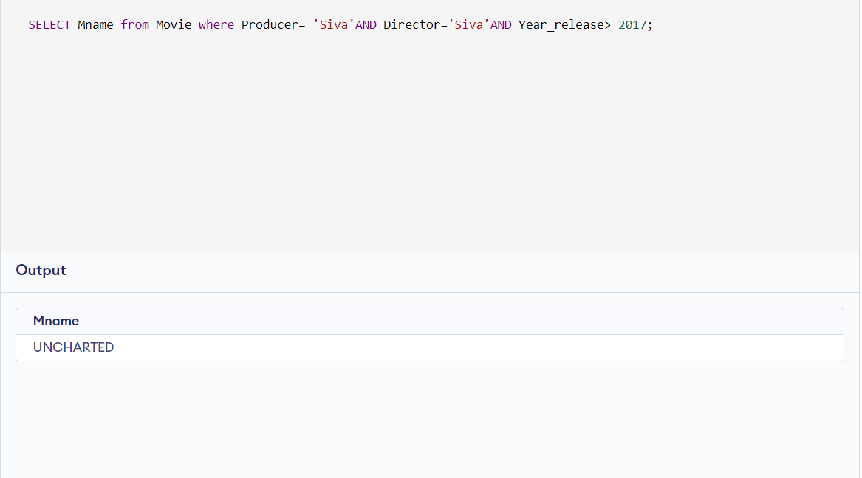

**Q.4** List the movies according the year of release

**ANS.**

SELECT Mname, Year_release from Movie ORDER BY Year_release ASC;

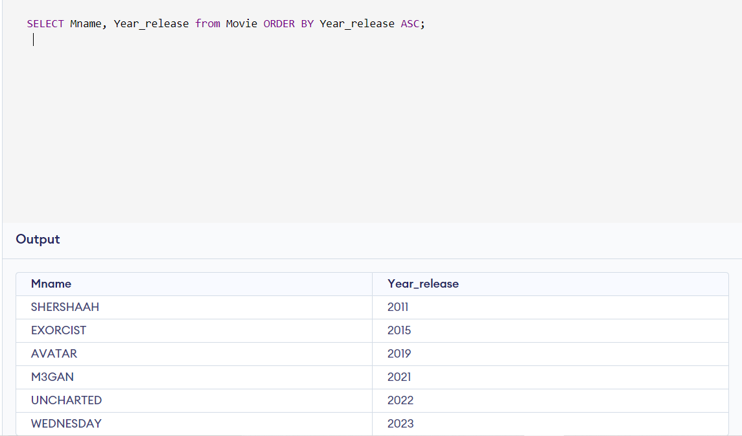

**Q.5** Find the movies and movie categories ordered by year casted by the actor Thilak.

**ANS.**

SELECT Mname, Movie_Category from Movie where Actor ="Thilak" ORDER BY Year_release ASC;

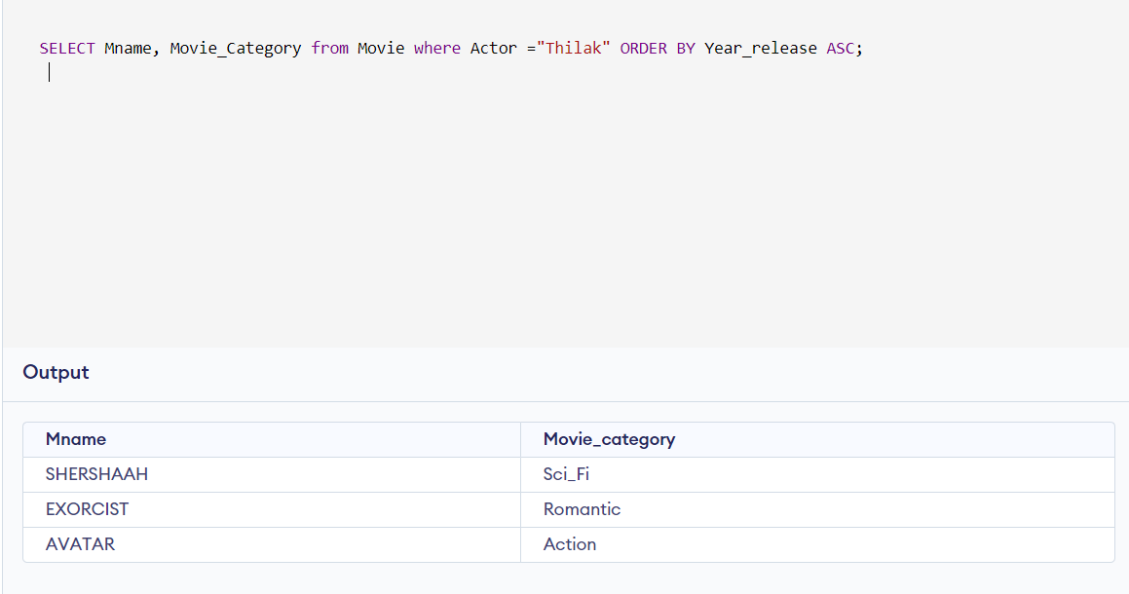

**Q.6** Find movies produced by Arunachalam after 2019.

**ANS.**

SELECT Mname from Movie where Producer="Arunachalam" AND Year_release >2019;

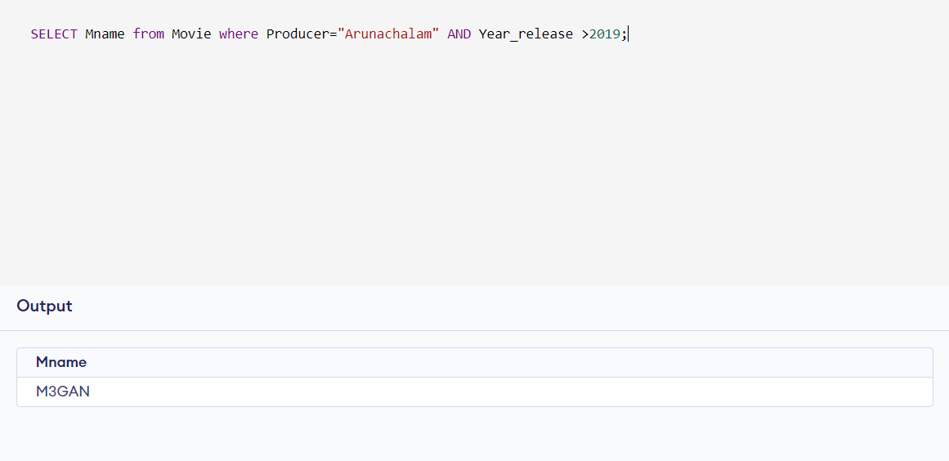

**PART 2**

**2) COMPANY TABLE**

CREATE TABLE EMPLOYEE(

EMPID int,

NAME varchar(30)

);

CREATE TABLE DEPARTMENT(

EMPID int ,

DEPTID int

);

CREATE TABLE PROJECT(

EMPID int,

PROJECT varchar(30)

);

CREATE TABLE WORKSON(

EMPID int ,

SUPERVISOR varchar(30),

HOURS int

);

CREATE TABLE DEPENDENT(

EMPID int,

NAME varchar(30)

);

INSERT INTO EMPLOYEE VALUES(116,'JOSEPH');

INSERT INTO DEPARTMENT VALUES(116 , 5);

INSERT INTO PROJECT VALUES(116, 'PROJECTX');

NSERT INTO WORKSON VALUES(116, 'FRANKLIN WORDS' ,13);

INSERT INTO DEPENDENT VALUES(116,'JOSEPH’ );

**i)**

SELECT DISTINCT * FROM EMPLOYEE WHERE EID IN (SELECT EID FROM DEPARTMENT WHERE DEPTID=5) AND EID IN (SELECT EID FROM WORKSON WHERE HOURS>=10) AND EID IN (SELECT EID FROM PROJECT WHERE PROJECT='PROJECTX');

**ii)**

SELECT EMPLOYEE.ENAME FROM EMPLOYEE, DEPENDENT WHERE EMPLOYEE.ENAME=DEPENDENT;

**iii)**

SELECT ENAME FROM EMPLOYEE WHERE EID IN (SELECT EID FROM WORKSON WHERE SUPERVISOR='FRANKLIN WORDS');